DiskImager User Guide

All basic info about DiskImager can be found in README file.
Contents
- Creating a backup copy of SD card/USB stick
- Restoring a SD card/USB stick from backup image
- Troubleshooting, additional information & links

Creating a backup copy of SD card/USB stick
In this tutorial I will be using SD card with firmware for TRIK robot which I want to back up to `.img` file zipped in XZ archive.
Plug in Your computer the SD card/USB stick you would like to back up. Then, open the DiskImager. You will see main window of a program.
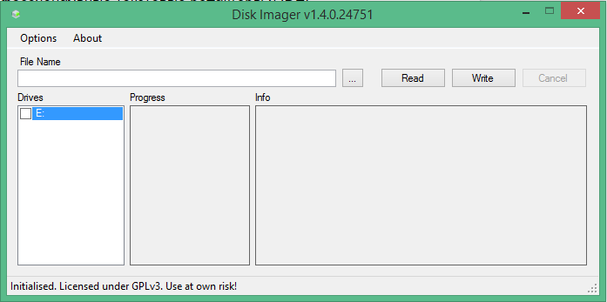
- Select the drive that You want to back up.
- After selecting a drive press `...` button to bring up dialog where You can choose a path and name for backup image that would be created.
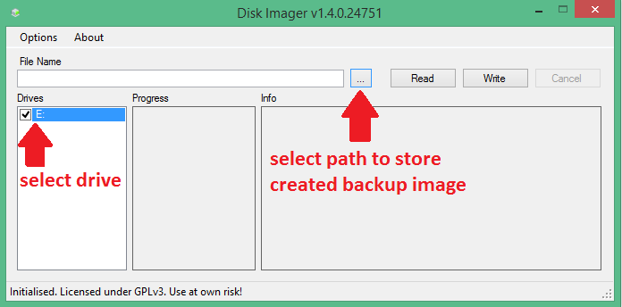
- Specify directory (it is a simple Windows file explorer dialog, so navigate as usual to a folder You like), name and file type for your backup image.
*Note: if you do not know which file type to choose, select XZ archive, because the resulting image will take less disk space on your computer.*
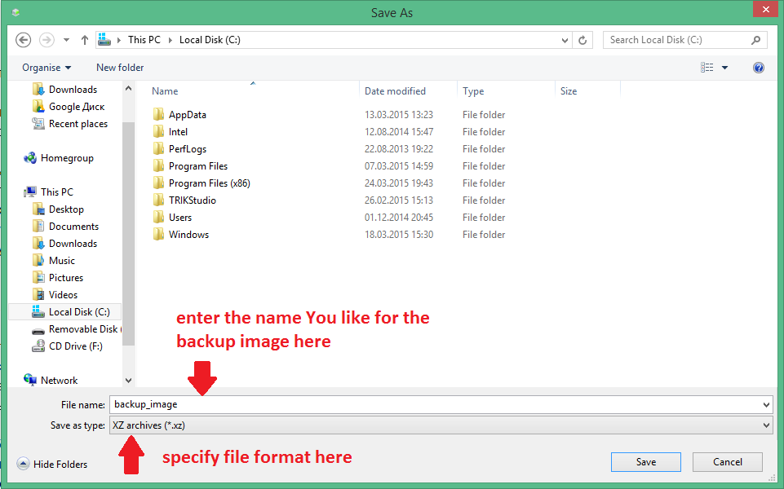

- Press `Read` button to start backing up.
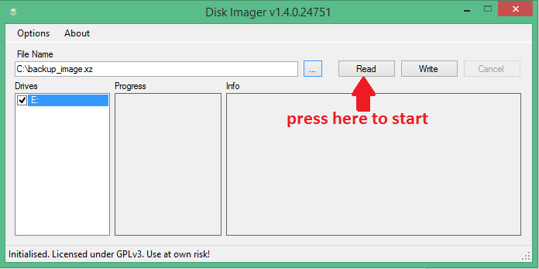
- Wait until utility performs requested operation.

Restoring a SD card/USB stick from backup image
In this tutorial, as an image, I will be using firmware for TRIK robot, which is `.img` file zipped in XZ archive.
Plug in Your computer the SD card/USB stick you would like to restore from your image. Then, open the DiskImager. You will see main window of a program.
- Choose the drives You want to restore
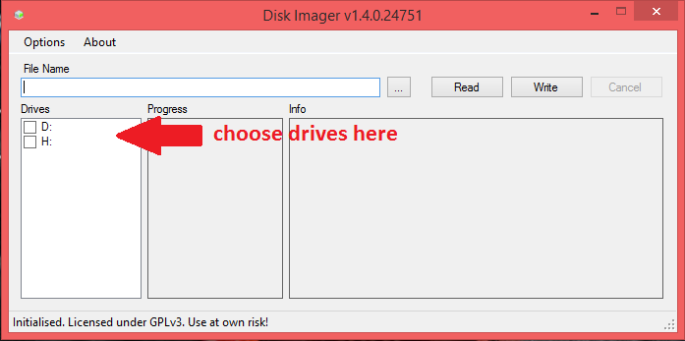

- Press `...` button to bring up dialog where You will be asked to choose a backup image. You can choose filter in the bottom of the dialog to set up extension filter.
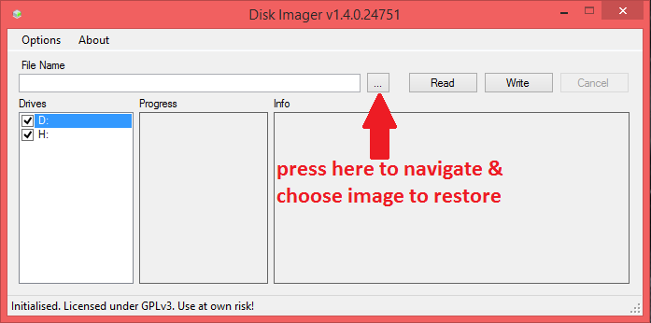

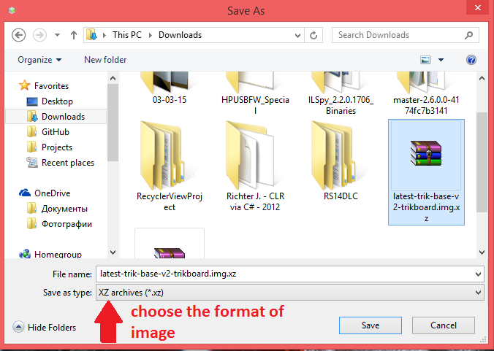

- Press `Write` button to start restoring from backup.
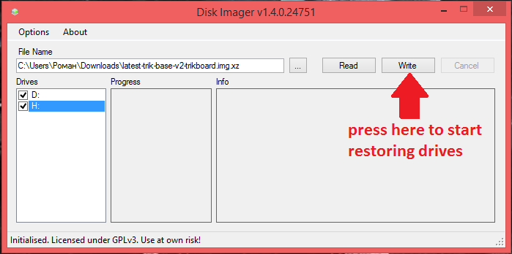
- Wait until utility performs requested operation.
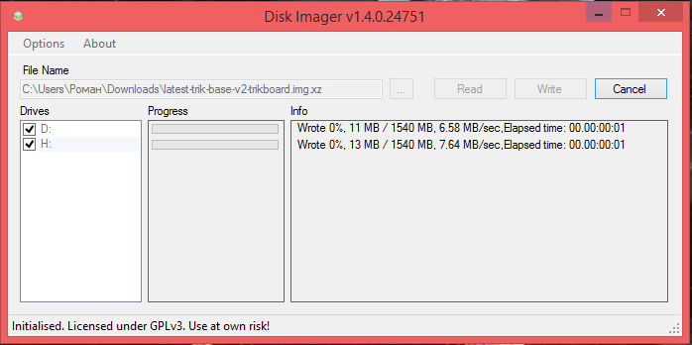

Troubleshooting
Question: I have plugged my SD card/USB stick in my computer, but DiskImager does not show it as available in the list of drives.
Answer: You can check out `Display all drives` in `Options` menu to show all drives attached to Your computer. *Be careful when turning this option on because it is possible to damage the data on Your main HDD if You accidentally pick it as a drive to read or write*. If it still would not be listed, You should check consistency of this drive.

Additional information
There are two options available at your choice at the `Options` menu
- `Use MBR sizes` allows you to read only data that is written in allocated MBR partitions. *By default this option is on, but You can turn it off to get a complete backup of Your drive.*
- `Unmount drives after write` safely removes drives from the system so You can unplug them after write without caring about data losses. *By default this option is on, but You can turn it off if You want to perform some operations with drives after writing image on them.*

